Project brief



Project Report

Status In progress

Timing Aug 7, 2025 to Date

Owners [Esther Adenike](mailto:orioyeesther2019@gmail.com)

# **Project Proposal**

## **A Project: Solar Energy Recommender System**

### **A. Project Description**

**1. Problem Statement:**Despite the growing need for clean, affordable, and reliable energy in Nigeria and many emerging markets, the adoption of solar energy remains significantly low among individuals, households, and small businesses. This is not due to a lack of interest, but rather the absence of accessible tools that can guide users in making informed decisions about solar energy solutions.

Key challenges include:

* **Component Mismatch**: Users often purchase under- or over-sized inverters, solar panels, and batteries due to inadequate technical knowledge, resulting in inefficiencies, increased costs, or system failure.
* **Lack of Price Transparency**: The absence of centralized platforms to compare product prices across e-commerce sites leads to uninformed and often expensive purchases.
* **Difficulty Finding Verified Installers**: Many users struggle to find qualified, trustworthy installers in their vicinity, leading to poorly installed or unsafe systems.
* **Low Awareness of Best Practices**: A significant portion of prospective solar users lack exposure to basic solar installation guidelines, safety tips, and practical dos and don'ts.

These challenges create barriers that limit the scale and success of solar energy adoption, especially for non-technical users seeking affordable energy independence.

**2. Project Objectives:**This project aims to build a Solar Energy Recommender System (MVP) that empowers users to make informed, cost-effective, and safe decisions about solar system installations, using real-world data and intelligent recommendations.

The Phase 1 objectives are:

1. Develop a load-based sizing engine that recommends the correct solar panel, inverter, and battery setup based on the user’s appliance input and energy needs.
2. Build an intelligent interface that translates simple appliance descriptions (e.g., “2 fans and 1 fridge”) into accurate load estimations using precompiled power rating datasets.
3. Scrape real-time product prices and specifications for solar components (panels, inverters, batteries) from e-commerce platforms like Jumia, Konga, and Solarkobo to aid comparison and affordability.
4. Curate a database of verified solar installers, sourced from online directories and social media platforms, to connect users with local professionals they can trust.
5. Provide users with structured educational content on best practices, installation safety, and common pitfalls through curated articles, videos, and FAQs.

All recommendations will be made available through a lightweight web-based interface (e.g., Streamlit or Flask) for easy access and scalability.

**3. Target Audience:**

* Homeowners interested in reducing electricity bills.
* Small and medium-sized businesses seeking sustainable energy solutions.
* Solar installation companies that want to provide quick recommendations to potential customers.
* Government agencies promoting renewable energy adoption.

### **B. Data Acquisition**

**Data Sources:**a. Appliance power ratings from manufacturer datasheets and public databases (e.g., Solarkobo, EnergyStar)

b. Solar panel, inverter, and battery specifications scraped from e-commerce platforms (e.g., Jumia, Konga, Solarkobo)

c. Installer information from online directories, business listings, and social media pages

d. Educational content from solar blogs, YouTube videos, and public guides

e. Currency exchange rates via free APIs (e.g., ExchangeRate-API) for accurate product pricing

**Feasibility:** Accessing solar and weather data is feasible via free APIs. Manufacturer data is publicly available, and electricity rates can be obtained from government and utility websites. Data collection can be completed in the **first two weeks** of the project.

### **C. Methodology**

**1. Data Analysis Techniques:**

* Apply GIS to map solar potential by location.
* Calculate average daily sunlight hours and irradiance for user location.
* Estimate energy generation capacity based on roof size and solar panel efficiency.

**2. Model Development:**

* Use collaborative filtering and content-based filtering to recommend optimal solar setups.
* Integrate machine learning regression models to predict energy savings and payback periods.
* Include budget-based filtering to match user affordability.

**3. Evaluation Metrics:**

* **Recommendation Accuracy**: Match between suggested systems and expert-reviewed solutions.
* **Prediction Error**: Mean Absolute Percentage Error (MAPE) in estimating cost savings.
* **User Satisfaction**: Feedback score from early testers.

### **D. Expected Outcomes and Deliverables**

**1. Project Success Metrics:**

* At least 90% accuracy in matching recommended solutions with expert assessments.
* Savings predictions with less than 10% error margin.
* Positive feedback from at least 80% of test users.

**2. Project Deliverables:**

* A fully functional solar recommender web application.
* A technical report detailing the data sources, methodology, and evaluation results.
* User guide and training materials for potential adopters (solar companies, agencies).

### **E. Potential Impact**

This system will make solar adoption easier, faster, and more affordable by providing accurate, location-specific recommendations. It will empower individuals and businesses to make informed decisions, boost renewable energy adoption, reduce electricity costs, and contribute to environmental sustainability.

### **F. Project Timeline**

**1. Project Duration:** The project will be completed in **2 months**.

**2. Key Stages and Deadlines:**

* **Week 1-2:** Data collection and preparation.
* **Week 3:** Prototype design of recommender system.
* **Week 4-5:** Model training and integration with GIS/solar datasets.
* **Week 6:** Testing and optimization.
* **Week 7:** Web interface development and user testing.
* **Week 8:** Final refinements, documentation, and deployment.

**3. Required Resources:**

* **Data:** Solar batteries datasets, panel specifications, electricity rates.
* **Software:** GIS tools, machine learning frameworks (Python, Scikit-learn, TensorFlow).
* **Hardware:** GPU-enabled server for training.
* **Personnel:** Data scientist, software developer, renewable energy consultant.

### **G. Budget**

**Cost Estimates:**

* Data Acquisition – Free (public datasets & APIs).
* Software and Tools – Mostly open-source.
* GPU Cloud Services – Not known yet
* Personnel – No cost (academic project).

**B Project: Energy Theft Detection System**

### **A. Project Description**

**1. Problem Statement:  
 Energy theft and unauthorized use of electricity without proper metering or payment is a significant challenge for utility companies worldwide. It results in huge financial losses, reduced power supply quality, and increased operational costs. In some regions, energy theft can account for more than 20% of total energy distribution losses, impacting both service providers and honest consumers.**

**Currently, many electricity distribution companies rely on manual inspections and basic anomaly detection methods to identify theft. However, these approaches are inefficient, costly, and prone to error. Imagine a utility company trying to inspect thousands of households manually detecting subtle, irregular usage patterns is nearly impossible without advanced analytics.**

**Our project aims to solve this by developing an Energy Theft Detection System that leverages smart meter data, historical consumption patterns, and machine learning algorithms to detect suspicious activity in real time.**

**2. Project Objective:  
 The main objective is to develop a data-driven, automated detection system that identifies potential cases of electricity theft with high accuracy and minimal false alarms. The system will:**

* **Monitor real-time and historical electricity consumption data.**
* **Detect abnormal usage patterns that indicate possible theft.**
* **Provide actionable alerts to utility companies for quick response.**
* **Offer analytical dashboards for monitoring theft trends across regions.**

**3. Target Audience:**

* **Electricity distribution companies.**
* **Government agencies regulating power distribution.**
* **Utility fraud investigation teams.**
* **Research institutions studying energy efficiency and loss prevention.**

### **B. Data Acquisition**

**Data Sources:  
 a. Smart meter readings from utility companies (hourly/daily consumption).  
 b. Historical billing and payment records.  
 c. Metadata about customer type, location, and meter type.  
 d. External data such as weather patterns, local outages, and seasonal effects.**

**Feasibility:  
 Smart meter and billing data are typically stored in utility databases and can be accessed under confidentiality agreements. Public datasets (e.g., from UCI Machine Learning Repository) can be used for model development and testing in early stages.**

### **C. Methodology**

**1. Data Analysis Techniques:**

* **Time-series analysis to detect sudden drops or spikes in consumption.**
* **Statistical anomaly detection to flag irregularities in energy usage patterns.**
* **Correlation analysis between consumption, weather, and billing trends.**

**2. Model Development:**

* **Use supervised learning (Random Forest, Gradient Boosting) for labeled theft detection datasets.**
* **Implement unsupervised anomaly detection (Isolation Forest, Autoencoders) for unlabeled cases.**
* **Combine detection models into an ensemble system for improved accuracy.**

**3. Evaluation Metrics:**

* **Precision & Recall: To measure theft detection accuracy.**
* **False Positive Rate: To ensure legitimate users aren’t wrongly flagged.**
* **Detection Time: Speed from theft occurrence to detection alert.**

### **D. Expected Outcomes and Deliverables**

**1. Project Success Metrics:**

* **90% detection accuracy with minimal false positives.**
* **Real-time detection capability with alerts under 5 minutes.**
* **Positive feedback from utility analysts during pilot tests.**

**2. Project Deliverables:**

* **A working prototype of the theft detection software with real-time alerting.**
* **Analytical dashboard showing theft cases, locations, and trends.**
* **Technical documentation and research report on detection methodology.**

### **E. Potential Impact**

**The system will reduce financial losses for power companies, improve supply reliability, and enhance fairness for paying customers. In the long term, it will discourage illegal connections, promote efficient energy usage, and support sustainable electricity distribution.**

### **F. Project Timeline**

**1. Project Duration:  
 The project will be completed in 3 months.**

**2. Key Stages and Deadlines:**

* **Week 1-2: Data collection and cleaning.**
* **Week 3-4: Exploratory data analysis and feature engineering.**
* **Week 5-7: Model development and training.**
* **Week 8-9: System integration and alert module development.**
* **Week 10: Testing and validation.**
* **Week 11: Dashboard and visualization setup.**
* **Week 12: Documentation and final deployment.**

**3. Required Resources:**

* **Data: Smart meter readings, billing history.**
* **Software: Python (Pandas, Scikit-learn, TensorFlow), data visualization tools.**
* **Hardware: GPU for model training, cloud server for deployment.**
* **Personnel: Data scientists, software engineers, utility domain experts.**

### **G. Budget**

**Cost Estimates:**

* **Data Acquisition – No cost (partnership with utility company).**
* **Software – Open-source tools.**
* **Cloud Hosting – Unknown yet.**
* **Personnel – No cost (academic/research project).**

**Research report**

| **Research report** | | |
| --- | --- | --- |
| Subject : **Solar Energy Recommender System** | Completed on **Aug 8, 2025** | Prepared by [**Esther Adenike**](mailto:orioyeesther2019@gmail.com) |

# **Introduction**

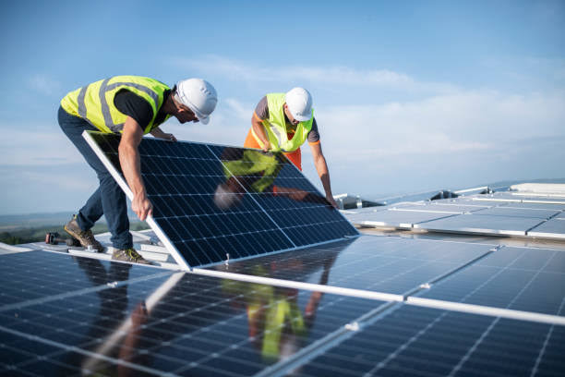

# **Literature review**

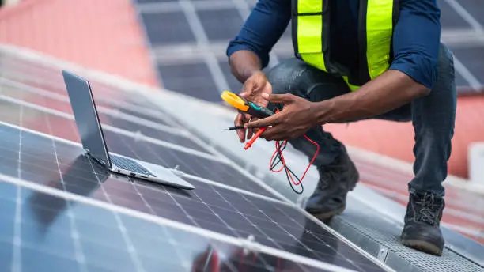

## Summary and analysis

Summarize the research findings. Highlight any key points you’ll expand on later.